EX.NO:04 | CLINIC MANAGEMENT APPOINTMENT SYSTEM
DATE:

1.AIM:
To develop a Clinic Management Appointment System using HTML, Bootstrap, and JavaScript that allows patients to book appointments and manage their appointment status.
2.PROCEDURE:
Step 1: Create an HTML page and include Bootstrap for responsive interface design.
Step 2: Design a form to collect patient details, doctor selection, date, and time.
Step 3 : Use JavaScript to store appointment data in localStorage.
Step 4 : Display the list of appointments dynamically on the webpage.
Step 5 : Provide options to confirm or cancel appointments and update the status accordingly.
3.PROGRAM SOURCE CODE :
Appointment.html
<!DOCTYPE html>
<html lang="en">
<head>
<meta charset="UTF-8">
<title>Clinic Appointment Booking System</title>
<meta name="viewport" content="width=device-width, initial-scale=1">

<!-- Bootstrap 5 CDN -->
<link href="https://cdn.jsdelivr.net/npm/bootstrap@5.3.2/dist/css/bootstrap.min.css" rel="stylesheet">

<style>
body {
background-color: #f4f6f9;
}
.card {
border-radius: 12px;
}
.badge-confirmed {
background-color: #28a745;
}
.badge-pending {
background-color: #ffc107;
color: black;
}
.badge-cancelled {
background-color: #dc3545;
}
</style>
</head>

<body>

<!-- Navbar -->
<nav class="navbar navbar-expand-lg navbar-dark bg-primary">
<div class="container">
<a class="navbar-brand" href="#">Clinic Appointment System</a>
</div>
</nav>

<!-- Booking Form -->
<section class="container my-5">
<div class="card shadow p-4">
<h3 class="mb-4">Book an Appointment</h3>
<form id="appointmentForm">
<div class="row">
<div class="col-md-6 mb-3">
<label class="form-label">Patient Name</label>
<input type="text" class="form-control" id="name" required>
</div>
<div class="col-md-6 mb-3">
<label class="form-label">Email</label>
<input type="email" class="form-control" id="email" required>
</div>
<div class="col-md-6 mb-3">
<label class="form-label">Select Doctor</label>
<select class="form-select" id="doctor" required>
<option value="">Choose...</option>
<option>Dr. Smith - Cardiologist</option>
<option>Dr. John - Dentist</option>
<option>Dr. Priya - Dermatologist</option>
<option>Dr. Kumar - General Physician</option>
</select>
</div>
<div class="col-md-3 mb-3">
<label class="form-label">Date</label>
<input type="date" class="form-control" id="date" required>
</div>
<div class="col-md-3 mb-3">
<label class="form-label">Time</label>
<input type="time" class="form-control" id="time" required>
</div>
</div>
<button type="submit" class="btn btn-primary w-100">Schedule Appointment</button>
</form>
</div>
</section>

<!-- Appointment List -->
<section class="container my-5">
<h3 class="mb-4">Manage Appointments</h3>
<div class="row" id="appointmentList"></div>
</section>

<script>
let appointments = JSON.parse(localStorage.getItem("appointments")) || [];
const form = document.getElementById("appointmentForm");
const list = document.getElementById("appointmentList");

form.addEventListener("submit", function(e) {
e.preventDefault();

const appointment = {
id: Date.now(),
name: document.getElementById("name").value,
email: document.getElementById("email").value,
doctor: document.getElementById("doctor").value,
date: document.getElementById("date").value,
time: document.getElementById("time").value,
status: "Pending"
};

appointments.push(appointment);
localStorage.setItem("appointments", JSON.stringify(appointments));
form.reset();
displayAppointments();
});

function displayAppointments() {
list.innerHTML = "";

appointments.forEach(app => {
let badgeClass = "badge-pending";
if (app.status === "Confirmed") badgeClass = "badge-confirmed";
if (app.status === "Cancelled") badgeClass = "badge-cancelled";

list.innerHTML += `
<div class="col-md-6 mb-4">
<div class="card shadow p-3">
<h5>${app.name}</h5>
<p><strong>Email:</strong> ${app.email}</p>
<p><strong>Doctor:</strong> ${app.doctor}</p>
<p><strong>Date:</strong> ${app.date}</p>
<p><strong>Time:</strong> ${app.time}</p>
<span class="badge ${badgeClass}">${app.status}</span>
<div class="mt-3">
<button class="btn btn-success btn-sm me-2"
onclick="updateStatus(${app.id}, 'Confirmed')">
Confirm
</button>
<button class="btn btn-danger btn-sm"
onclick="updateStatus(${app.id}, 'Cancelled')">
Cancel
</button>
</div>
</div>
</div>
`;
});
}

function updateStatus(id, status) {
appointments = appointments.map(app => {
if (app.id === id) {
app.status = status;
}
return app;
});

localStorage.setItem("appointments", JSON.stringify(appointments));
displayAppointments();
}

displayAppointments();
</script>
</body>
</html>
4.SAMPLE INPUT / OUTPUT
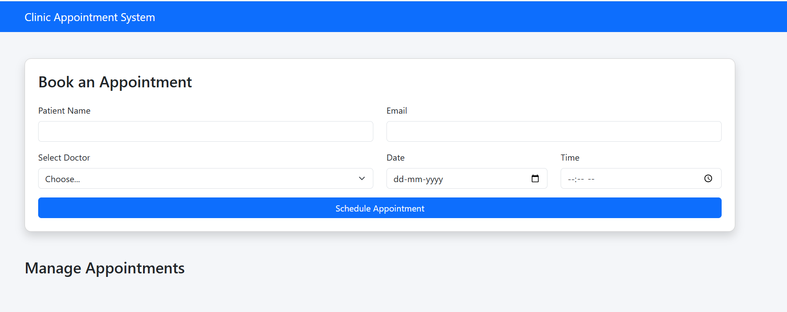
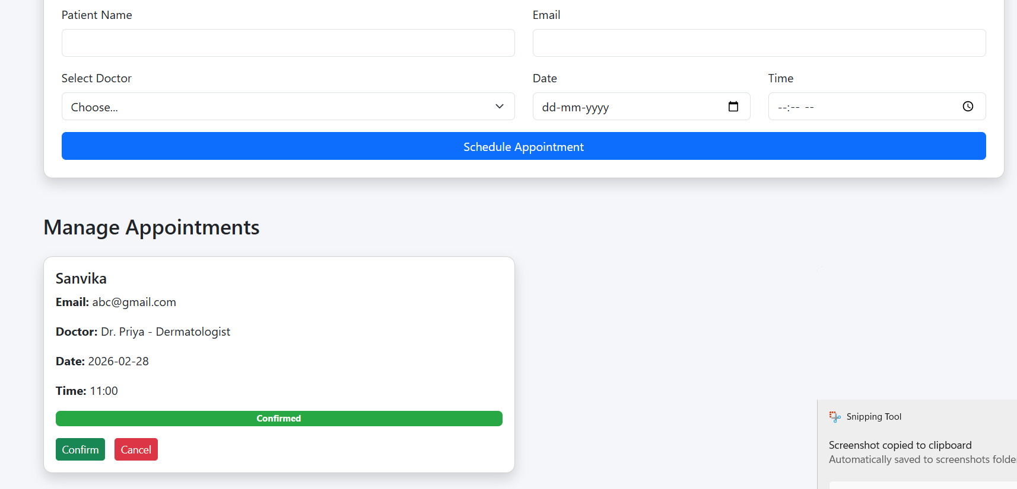

5.RESULT:
The Clinic Appointment Booking System was successfully developed. Users can schedule appointments, view them, and update their status as Pending, Confirmed, or Cancelled.

